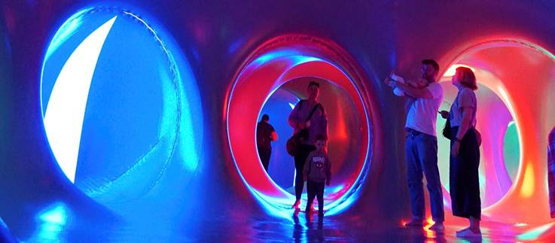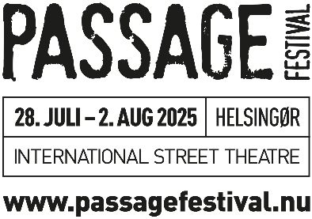

INVITATION TO PRESS PREVIEW

MYRIAD LUMINARIUM af Architects of Air (UK)
Passage Festival invites you to a Press Preview in MYRIAD LUMINARIUM:

WEDNESDAY 30. JULY 2025 – 16:00
Venue: Kulturhavn Kronborg, Helsingør
Registration and more information:
Camilla Hasseriis Dietz, pr@helsingor-teater // +45 53 84 08 11

On the way from the town towards Helsingør’s great museum flagships, Kronborg Castle and the Maritime Museum of Denmark, visitors will next week encounter a sensuous, almost psychedelic sight, as the world-famous Architects of Air (UK) let their newest MYRIAD LUMINARIUM, a 900 m² labyrinth of air, light and color up to 8 meters high, reign on the city’s culture harbor as part of the annual international Passage Festival

WHAT IS MYRIAD LUMINARIUM
VIDEOS from other luminariums:
The National Festival of Making in Blackburn, UK | The Colours of the Moorlands in Leek, UK

A large monumental sculpture of domes and onion-shaped spires up to 8 meters high.
A 900 m² interactive sensory installation of air, light and color.
150 meters long | 32 meters wide | Highest dome: approx. 8 meters
Inspired by the stars – the myriad points of light we lose ourselves in on the night sky: When entering the artistic labyrinth of winding passages, floating domes and colored light, Archimedean solids and Gothic cathedrals melt together into a unique sensory experience for all ages.
Handmade (each panel is hand-cut and glued) in PVC material less than 0.5 mm. Like an aquarium encloses water, a luminarium encloses and holds light: Without light, there are no colors in the luminarium. When daylight shines through the thin membranes, fantastic colors and spaces of light are created inside the installation.
Architects of Air’s luminaria have been experienced by more than 3 million visitors worldwide since 1992. MYRIAD LUMINARIUM is their newest installation, premiered in May 2025.
Interviews, on site or in studio: Founder of Architects of Air, designer Alan Parkinson, will be in Helsingør from Thursday 31 July – Sunday 3 August.
www.architects-of-air.com

INFO
Opening hours at Passage Festival
Thursday 31. July – 12:00-16:30
Friday 1. august – 13:15-18:00
Saturday 2. august – 13:15-16:30

Continuous access during opening hours. Start and end times indicate first / last entry.
Free Admission

PASSAGE FESTIVAL 28. JULI – 2. AUGUST 2025

